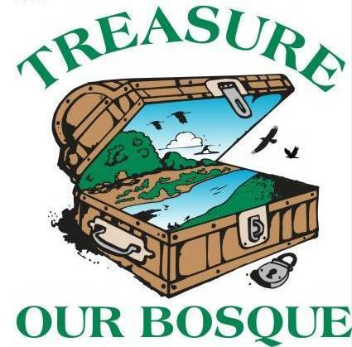
Save Our Bosque Task Force Board Meeting
Socorro County Annex Office
198 Neel Ave.
Socorro NM

Tuesday, May 5th @ 3:00pm
Meeting Location: Conference call
In attendance: Gina Dello Russo, Amy Erickson, Sandra Noll, Sarah Anderson, Matt Mitchell, Kyle Trujillo, Renee Robichaud, Micah Moore, Yasmeen Najmi, Abigail Plecki
Meeting began at 3:03 pm.
1. Approve Agenda – Matt motions to approve agenda, Sandra seconds, passed.

2. Approve Minutes from March meeting – Matt motion, Sandra second, passed

3. Action Items:

- Sarah will schedule a board retreat to discuss advocacy issues and other matters
- Sarah will contact Socorro Consolidated Schools to set up a day in October to have Bosque Conservation Day
- Matt will set up a time to visit the Barclay property and invite Amy, Sandra, Sarah and Gina
- Sarah will set up a meeting with Chad to discuss ravennagrass control
- Gina will look into having the board retreat at the Sevilleta outdoor classroom
- Yasmeen will ask about remaining MRGCD funds allocated for Bosque Conservation Day (may be re-allocated for budget shortfalls)
- All – Send Amy or Sarah calendar items to put on our website calendar. Send Amy or Sarah updates, stories, pictures, etc to put on the Facebook or Instagram page.

4. Treasurer’s Report
We had a beginning balance of $47,834.48 and an ending balance of $40,654.28. Rhodes property sediment removal is pending which is a large chunk of the remaining funds. There was a drawdown from PFW for admin cost for $4400 which will go into our general fund. We applied for and received a government loan from the Paycheck Protection Program in the amount of $9520.00. This money may be converted to a grant (which we don’t have to pay back) if certain requirements are met.

5. Fundraising update
The board had a fundraising meeting last week where we discussed our budget spreadsheet and where all of our funding comes from and goes to. We need additional funding for capacity, including program director salary and interns.

6. Interns update
Sarah posted the job announcement on Facebook and Instagram and Amy shared it as well. One intern has been hired and will start Monday, May 18th. The second intern has not been selected yet and will start a little later in the season. We came to an agreement that the interns will be housed at Matt Mitchell’s AirBNB due to COVID-19 restrictions at the Sevilleta field housing.

7. Community Outreach
Sandra cleaned up and took inventory on the 5 bosque parks south of Otero. She reported that Brown Arroyo and San Acacia parks have heavy use and there was quite a lot of trash. Additionally, the concrete picnic table at Brown Arroyo is very torn up and Cottonwood Grove park has a large tree branch down on the table and one of the grills there is destroyed. Most of the cement fire rings are chipped/worn and some are mostly disintegrated. We discussed the feasibility of putting out trash cans at some of the parks but previously that led to people bringing their trash from town to the river to dump it. We discussed creating bilingual signs to pack in/pack out trash – we could look at small grants for this.

Bosque Conservation Day – Matt is contacting the school principles to find a day for BCD that works for everyone.

8. Advocacy
We don’t have funding for a facilitator at this point. Kathy Granillo may be able to facilitate the meeting. We agreed to do this in person in an outdoor space so we can do social distancing. We can use the Sevilleta outdoor classroom or the Socorro Nature Area. Gina will check into this.

9. Project Updates

Rio Grande Trail / Socorro Valley Trail
Yasmeen will check in with Attilla. There is still a student working on the maps but nothing else has moved forward. Since Sarah does not have funding to do any work on the SVT, Yasmeen will take over as project lead.

BOR Cooperative Agreement
One intern has been selected and will start May 18 and work until Aug 14. He has experience with anthropological ecology but wants more field work experience. Rhodes property will have weed spraying done soon and Sarah has been pulling weeds. The interns will have a 4x4 rental truck to use for field work. We will be hiring a second intern but have not selected one at this point.

Partners for Fish and Wildlife
Matt gave an update –
Conklin project – Angel said to cut the budget down for Conklin, and the agreement will be ready to sign soon. Sandra is talking with the Barclay’s and they want to move ahead with a project and they have clarified their water rights. Matt, Amy and Gina can schedule a trip to go out there.

Sevilleta
Field work – Kathy sent Sarah information on projects and she will visit the project areas within the next couple weeks. They are still on mandatory telework until at least May 23rd.

Tiffany Fire
Abigail gave an update about her new position as Timber Management Officer. The project units are moving along and she will go out to inspect the site soon.

WaterSmart Grant
The geodatabase is in draft form and Chad, Yasmeen, Ashlee (BOR) and Grace (ISC) are reviewing the geodatabase. Next product will be the draft of the “state of the river reach” report. The contract has been extended until June 30th.

NMC Grant
Gina is taking the lead on this project. The contractor started mulching yesterday and Gina went out to inspect. We have permission to work in the area as long as we look for ground-nesting birds. Contractor will probably be done by next week. They will spot-spray by June 30th.

Other
Bosque ribbon project – the crew isn’t working right now because of SWFL restrictions.

10. Adjourn
Matt moved and Sandra second. Passed. Adjourned at 4:11 pm

Next meeting will be Tuesday, June 2nd at 3:00pm.

